
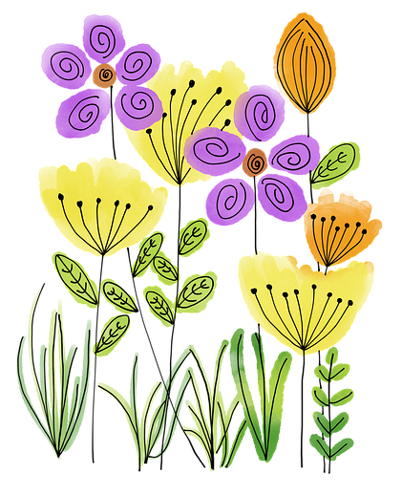
Bridge of Don
Gardening Competition

Name:

Address:

Email address:

Category entered (please circle):

Garden Display / Fruit and Veg / Tallest Sunflower

I can confirm that I would like to take part in the Garden Competition, and am happy for pictures of my garden to be shared on the Bridge of Don Community Council website/Facebook page.

Signed:

