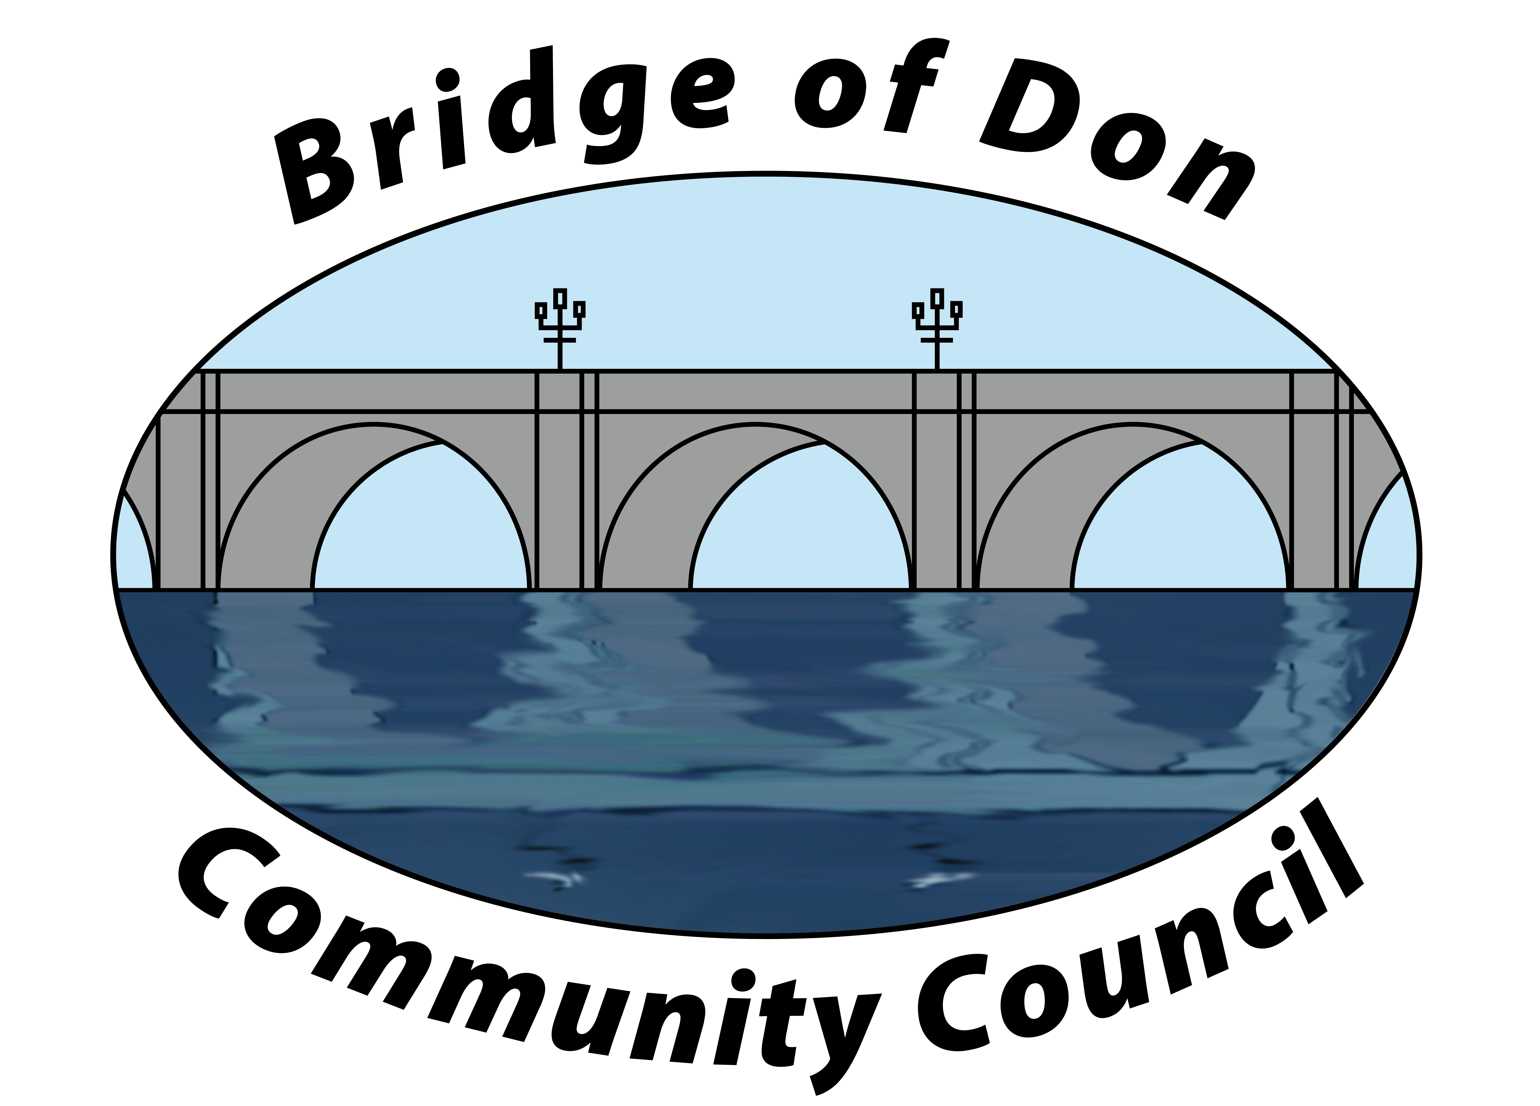

AGENDA FOR TUESDAY JANUARY 16th 2024
7.30pm AT SCOTSTOWN PRIMARY SCHOOL

1 | ATTENDANCE & APOLOGIES
2 | PUBLIC QUERIES
3 | POLICE REPORT
4 | ADOPTION & MATTERS ARISING MINUTES FROM DECEMBER 2023
5 | COUNCILLORS’ REPORTS
6 | TREASURER’S REPORT
7 | PLANNING
8 | REPORTS:  Friends of Westfield Park - BoD Reserves - Health & Social Care  CC Forum - Better BOD
9 | CORRESPONDENCE
10 | A.O.C.B. –  Facebook
10 | DATE AND TIME OF NEXT MEETING 20th February 2024

Meeting dates - 3rd Tuesday of the month: 20th February, 19th March, 16th April, 21st May
Meetings will be held at Scotstown Primary School unless otherwise stated.

If residents would like to attend any meeting, please let us know in advance by getting in touch with us at bodccsec@btinternet.com or via a private message on our Facebook page.

