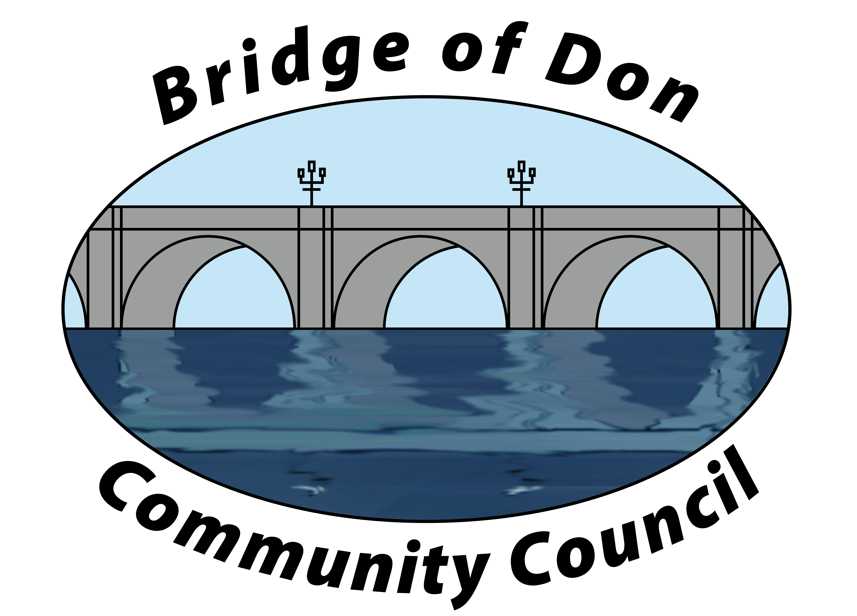

AGENDA FOR TUESDAY FEBRUARY 20th 2024
7.30pm SCOTSTOWN PRIMARY SCHOOL

A.G.M.
1 | ATTENDANCE AND APOLOGIES
2 | CHAIRPERSON’S REPORT
3 | TREASURER’S REPORT
4 | DATE OF NEXT A.G.M.
MONTHLY MEETING
1 | PUBLIC QUERIES
2 | POLICE REPORT
3 | ADOPTION & MATTERS ARISING MINUTES FROM JANUARY 2024
4 | COUNCILLORS’ REPORTS
5 | TREASURER’S REPORT
6 | PLANNING
7 | REPORTS:  Friends of Westfield Park - BoD Reserves - Health & Social Care  CC Forum - Better BOD
8 | CORRESPONDENCE
9 | A.O.C.B. –  Facebook  It’s Your Neighbourhood  CC elections
10 | DATE AND TIME OF NEXT MEETING 19th March 2024

Meeting dates - 3rd Tuesday of the month: 19th March, 16th April, 21st May, 18th June

Meetings will be held at Scotstown Primary School unless otherwise stated.

If residents would like to attend any meeting, please let us know in advance by getting in touch with us at bodccsec@btinternet.com

