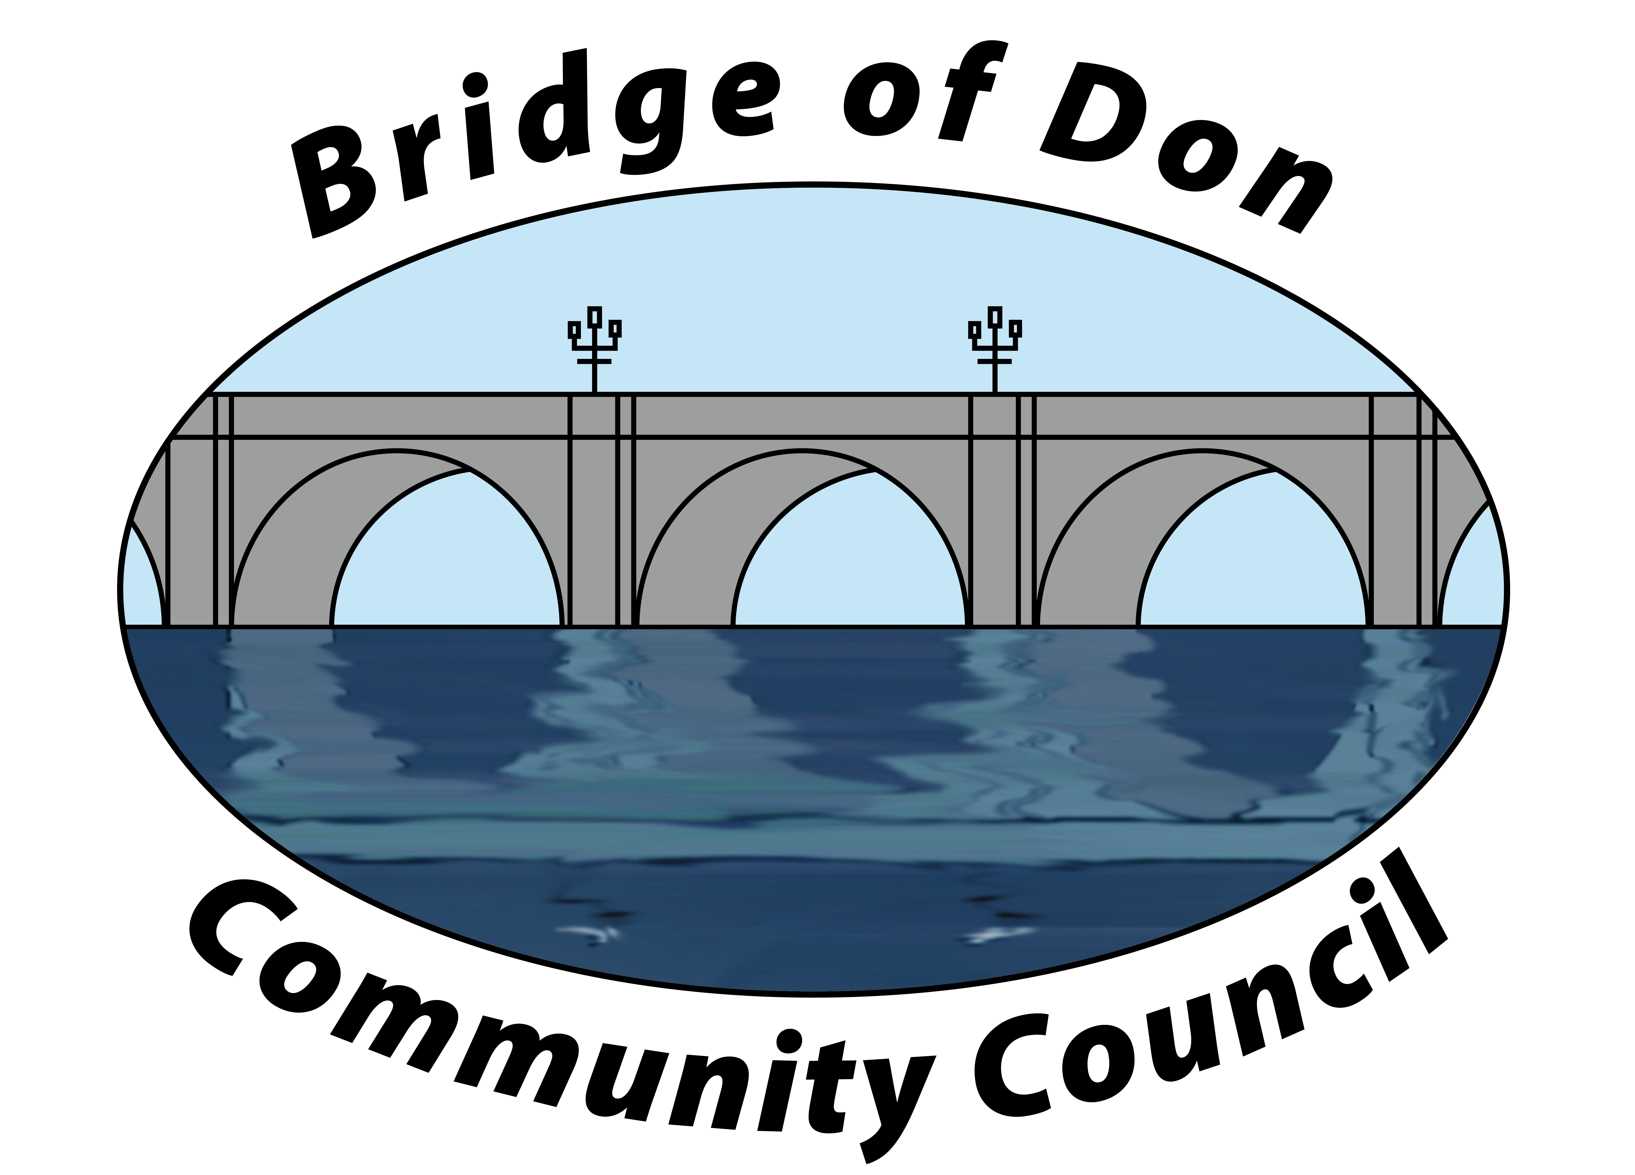

AGENDA FOR TUESDAY AUGUST 20th 2024
7.30pm SCOTSTOWN PRIMARY SCHOOL

1 | ATTENDANCE AND APOLOGIES
2 | PUBLIC QUERIES
3 | POLICE REPORT
4 | ADOPTION & MATTERS ARISING MINUTES FROM JUNE 2024
5 | COUNCILLORS’ REPORTS
6 | TREASURER’S REPORT
7 | PLANNING
8 | REPORTS:  Friends of Westfield Park - BoD Reserves - Health & Social Care  CC Forum - Better BOD
9 | CORRESPONDENCE
10 | A.O.C.B. –  War Memorial update  It’s Your Neighbourhood update  CC elections  Absafe invitation  Westfield Park works
11 | DATE AND TIME OF NEXT MEETING 17th September 2024

Meeting dates - 3rd Tuesday of the month: 17th September, 15th October (Zoom), 19th November, 10th December (Zoom)

Meetings will be held at Scotstown Primary School unless otherwise stated.

If residents would like to attend any meeting, please let us know in advance by getting in touch with us at bodccsec@btinternet.com

