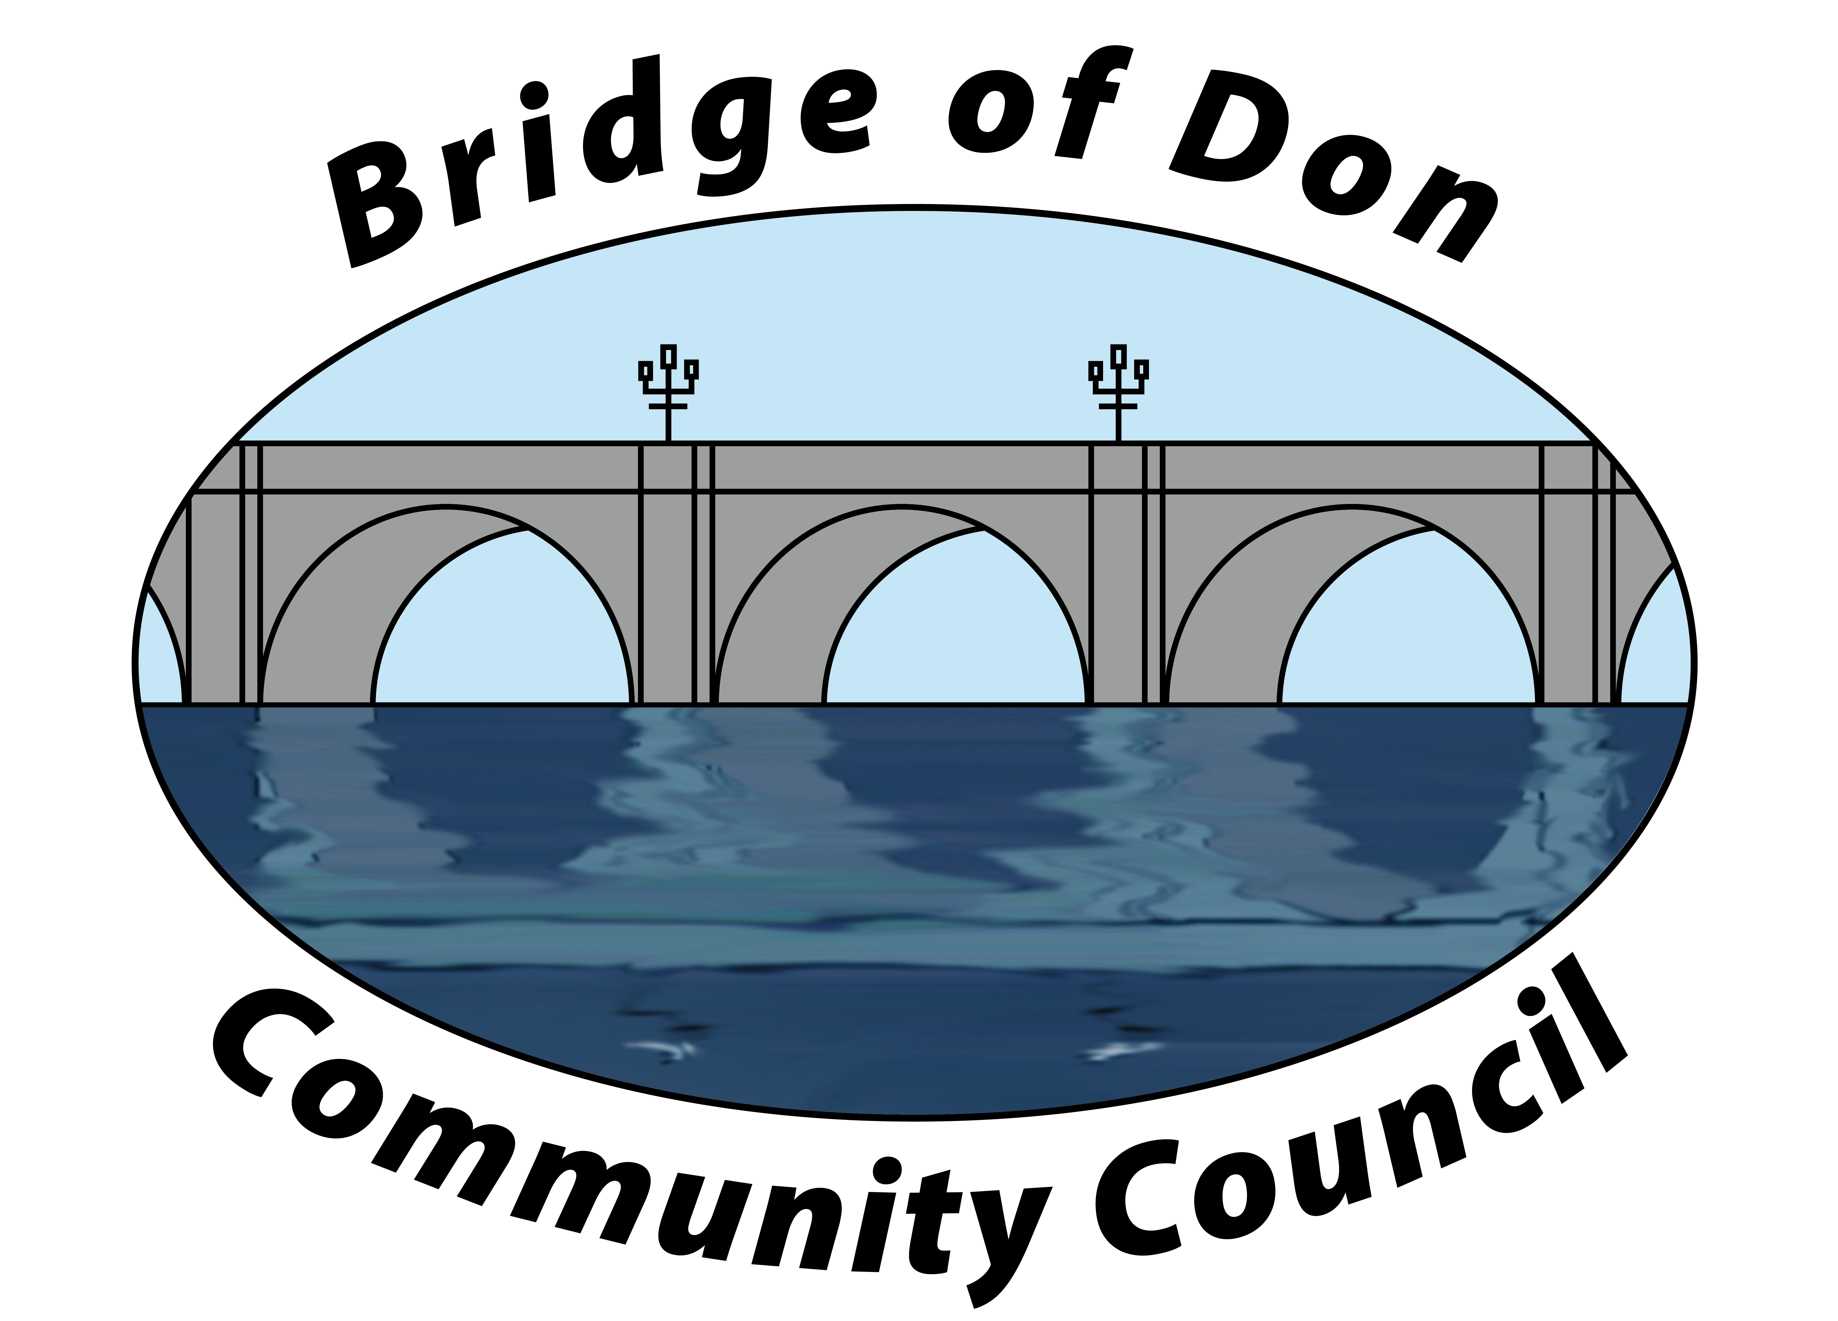

AGENDA FOR TUESDAY FEBRUARY 18th 2025
7.30pm SCOTSTOWN PRIMARY SCHOOL

A.G.M.
1 | ATTENDANCE AND APOLOGIES
2 | CHAIRPERSON’S REPORT
3 | TREASURER’S REPORT
4 | DATE OF NEXT A.G.M.
MONTHLY MEETING
1 | ADOPTION & MATTERS ARISING MINUTES FROM JANUARY 2025
2 | PUBLIC QUERIES
3 | POLICE REPORT
4 | COUNCILLORS’ REPORTS
5 | TREASURER’S REPORT
6 | PLANNING
7 | REPORTS:  Friends of Westfield Park - BoD Reserves - Health & Social Care  CC Forum - Better BOD
8 | CORRESPONDENCE
9 | A.O.C.B. –  Members’ interests / 2025 goals and events  Fundraising
10 | DATE AND TIME OF NEXT MEETING 18th March 2025

Meeting dates - 3rd Tuesday of the month: 18th March, 15th April, 20th May, 17th June (no July meeting)

Meetings will be held at Scotstown Primary School unless otherwise stated.

If residents would like to attend any meeting, please let us know in advance by getting in touch with us at bodccsec@btinternet.com

