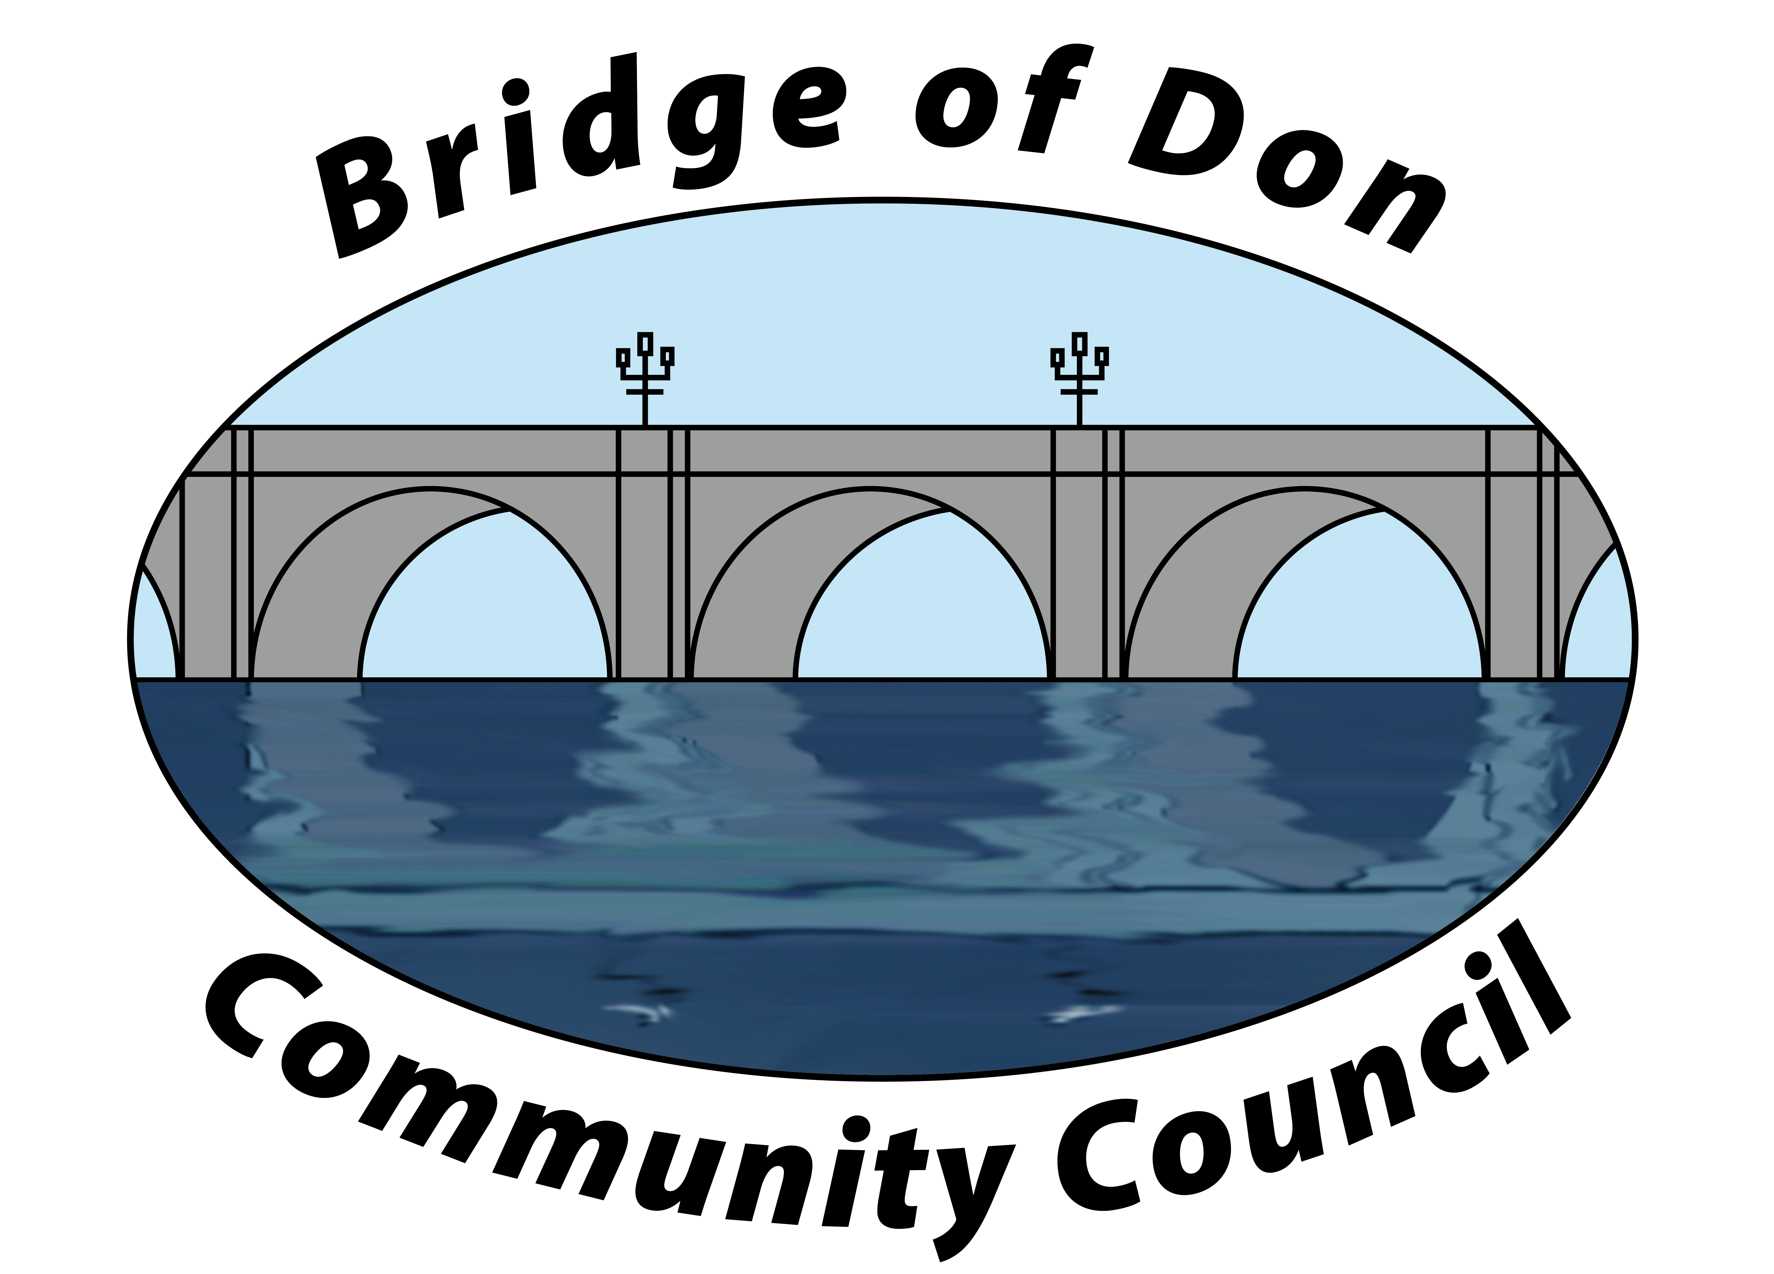

AGENDA FOR TUESDAY AUGUST 19th 2025
7.30pm SCOTSTOWN PRIMARY SCHOOL

1 | ADOPTION & MATTERS ARISING MINUTES FROM JUNE
2 | PUBLIC QUERIES
3 | POLICE REPORT
4 | COUNCILLORS’ REPORTS
5 | TREASURER’S REPORT
6 | PLANNING
7 | REPORTS:  Friends of Westfield Park - BoD Reserves - Health & Social Care  CC Forum - Better BOD
8 | CORRESPONDENCE
9 | A.O.C.B.  British Legion  NE Scotland Coastal Trust
10 | DATE AND TIME OF NEXT MEETING 16th SEPTEMBER 2025

Meeting dates - 3rd Tuesday of the month: 16th September, 21st October (at Mens Shed)

Meetings will be held at Scotstown Primary School unless otherwise stated.

If residents would like to attend any meeting, please let us know in advance by getting in touch with us at bodccsec@btinternet.com

