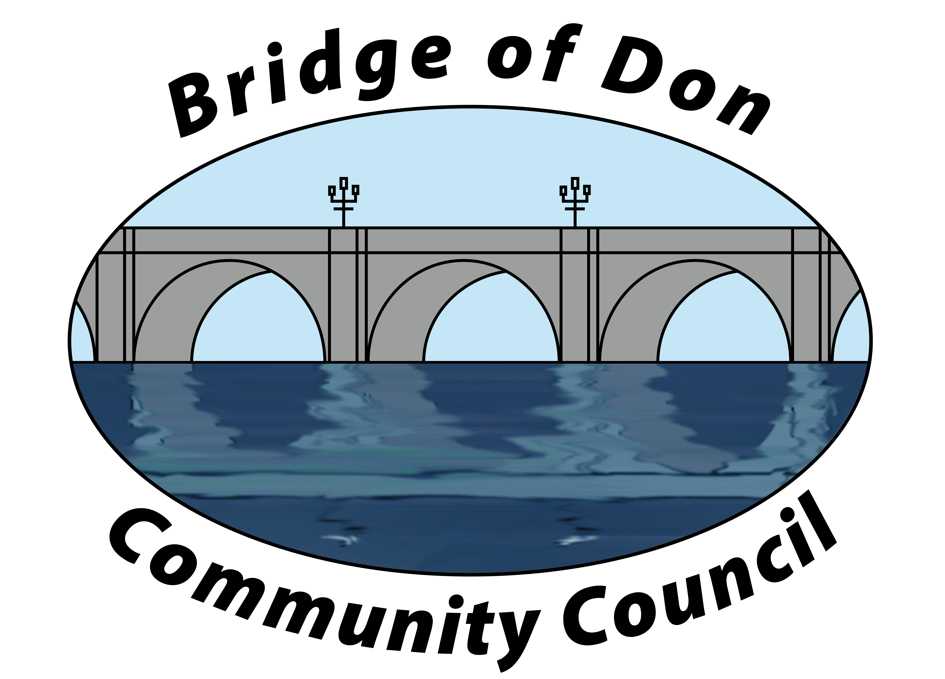

AGENDA FOR TUESDAY SEPTEMBER 16th 2025
7.30pm SCOTSTOWN PRIMARY SCHOOL

1 | ADOPTION & MATTERS ARISING MINUTES FROM AUGUST
2 | PUBLIC QUERIES
3 | POLICE REPORT
4 | COUNCILLORS’ REPORTS
5 | TREASURER’S REPORT
6 | PLANNING
7 | REPORTS:  Friends of Westfield Park - BoD Reserves - Health & Social Care  CC Forum - Better BOD
8 | CORRESPONDENCE
9 | A.O.C.B.  New benches  November/December meetings  Producers’ Market
10 | DATE AND TIME OF NEXT MEETING 21st OCTOBER 2025

Meeting dates - 3rd Tuesday of the month: 21st October (at Mens Shed)

Meetings will be held at Scotstown Primary School unless otherwise stated.

If residents would like to attend any meeting, please let us know in advance by getting in touch with us at bodccsec@btinternet.com

