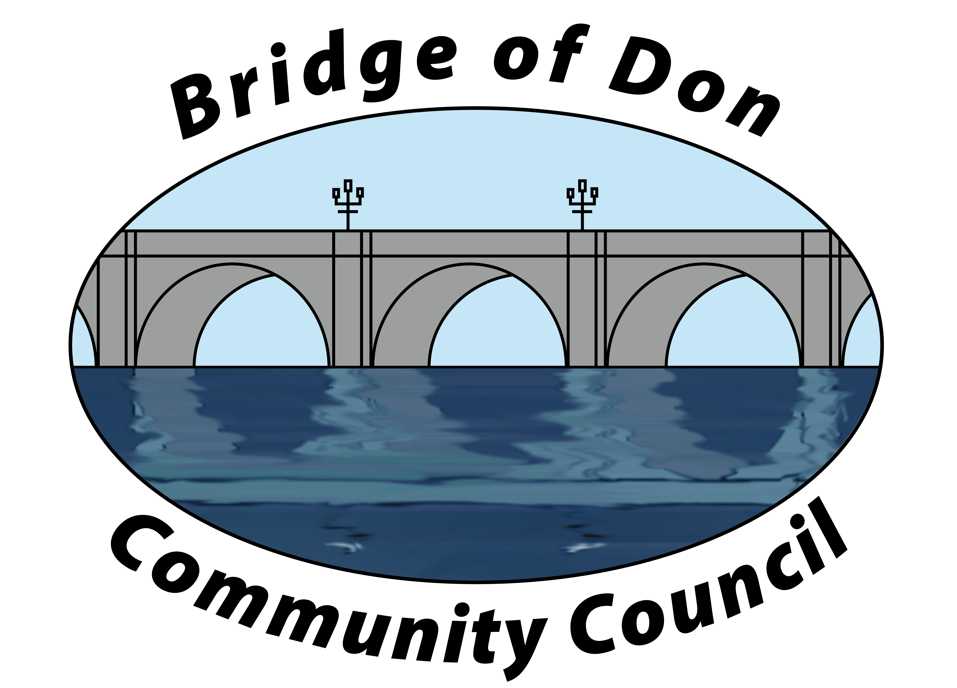

AGENDA FOR TUESDAY FEBRUARY 17th 2026, 7.30pm
SCOTSTOWN PRIMARY SCHOOL

A.G.M.
1 | ATTENDENCE & APOLOGIES
2 | CHAIRPERSON’S REPORT
3 | TREASURER’S REPORT
4 | DATE OF NEXT A.G.M
MONTHLY MEETING
1 | MATTERS ARISING FROM JANUARY MINUTES
2 | PUBLIC QUERIES
3 | POLICE REPORT
4 | COUNCILLORS’ REPORTS
5 | TREASURER’S REPORT
6 | PLANNING
8 | REPORTS:  Friends of Westfield Park - BoD Reserves - Health & Social Care  CC Forum - Better BOD
8 | CORRESPONDENCE
9 | A.O.C.B.  Royal Garden Party invite - nominations
10 | DATE AND TIME OF NEXT MEETING 17th MARCH 2026

Meeting dates 2026 – 17th March, 21st April, 19th May, 16th June

Meetings will be held at Scotstown Primary School unless otherwise stated (Winter meetings may be via Zoom, depending on weather).

If residents would like to attend any meeting, please let us know in advance by getting in touch with us at bodccsec@btinternet.com

