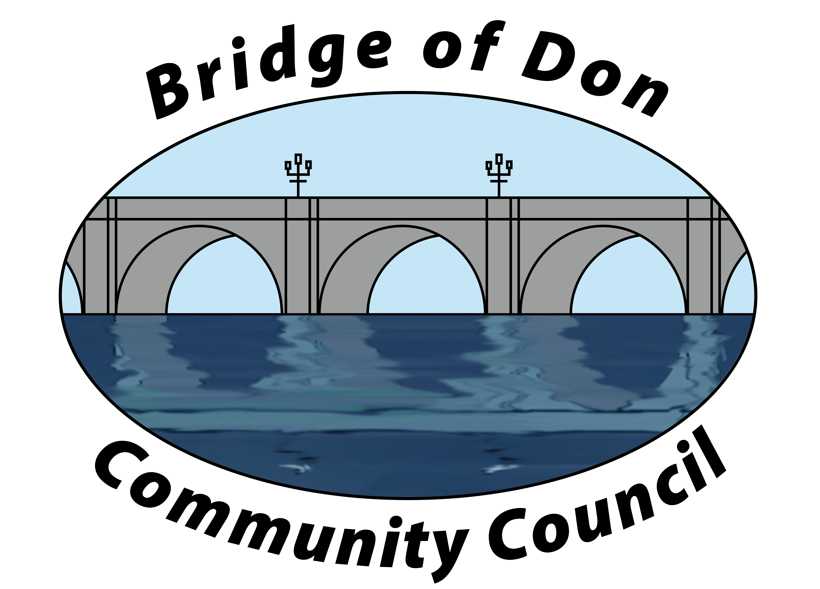

AGENDA FOR TUESDAY AUGUST 18th 2026, 7.30pm
VENUE TBC (HOPEFULLY SCOTSTOWN SCHOOL)

1 | ADOPTION & MATTERS ARISING MINUTES FROM JUNE
2 | PUBLIC QUERIES
3 | POLICE REPORT
4 | COUNCILLORS’ REPORTS
5 | TREASURER’S REPORT
6 | PLANNING
8 | REPORTS:  Friends of Westfield Park - BoD Reserves - Health & Social Care  CC Forum – Spotted Issues
8 | CORRESPONDENCE
9 | A.O.C.B.  Secretary position  Location for October meeting  Zoom renewal  VOI parking
10 | DATE AND TIME OF NEXT MEETING 15th SEPTEMBER

Meeting dates 2026 – 15th September, 20th October (venue TBC), November & December dates TBC

Meetings will be held at Scotstown Primary School unless otherwise stated (Winter meetings may be via Zoom, depending on weather).

If residents would like to attend any meeting, please let us know in advance by getting in touch with us at bodccsec@btinternet.com

