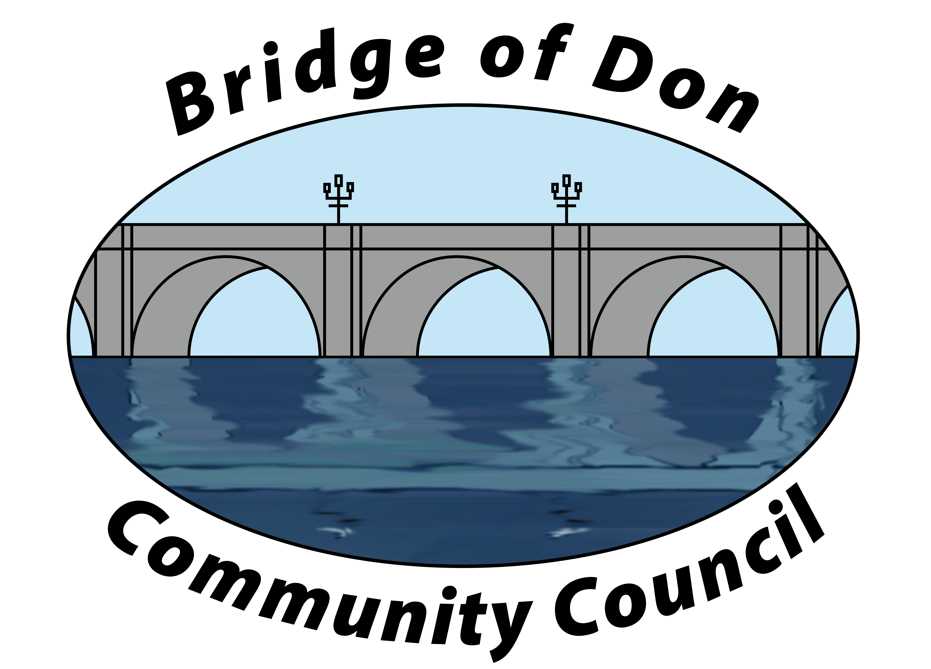

AGENDA FOR TUESDAY AUGUST 15th 2026, 7.30pm
AT SCOTSTOWN SCHOOL

1 | ADOPTION & MATTERS ARISING MINUTES FROM AUGUST
2 | PUBLIC QUERIES  Community involvement  Bird feeding area
3 | POLICE REPORT
4 | COUNCILLORS’ REPORTS
5 | TREASURER’S REPORT
6 | PLANNING
8 | REPORTS:  Friends of Westfield Park - BoD Reserves - Health & Social Care  CC Forum – Spotted Issues
8 | CORRESPONDENCE
9 | A.O.C.B.  Update from Karen
10 | DATE AND TIME OF NEXT MEETING 20th OCTOBER - MENS SHED

Meeting dates 2026: 20th October (at MENS SHED), 17th November, 8th December (ZOOM call)

Meetings will be held at Scotstown Primary School unless otherwise stated (Winter meetings may be via Zoom, depending on weather).

If residents would like to attend any meeting, please let us know in advance by getting in touch with us at bodccsec@btinternet.com

